Task: Design the data flow for a ride-sharing application (like Uber).
Requirements: Identify all external entities, major processes, data stores, and data flows.
Create a Level 0 (Context) DFD and provide plantuml code.
Create a Level 1 DFD, decomposing the main system process and provide plantuml code.
For every data store in the DFD, design the corresponding normalized (3NF) database tables - provide cre
Create a presentation (using Google Slides or PowerPoint) that walks through your DFDs and explains how they map to your database schema design.
Deliverable: A link to the presentation and a GitHub repository with the DFD diagrams and a .sql file for the schema.
This task involves designing a comprehensive system architecture for a ride-sharing platform. Below is the breakdown of the Data Flow Diagrams (DFDs), the normalized database schema, and the requested deliverables.

1. Level 0: Context Diagram (DFD)
The Context Diagram defines the system boundary, showing how the Ride-Sharing System interacts with external entities.
External Entities:
- Rider: Requests rides, makes payments, and rates drivers.
- Driver: Accepts/rejects requests, updates trip status, and receives payments.
- Payment Gateway: Processes financial transactions.
- Maps API: Provides routing and distance data.
PlantUML Code (Context DFD):
Code snippet
@startuml
!define ENTITY class
left to right direction

entity "Rider" as R
entity "Driver" as D
entity "Payment Gateway" as PG
entity "Maps API" as M

package "Ride-Sharing System" {
process "Main System" as S
}

R --> S : Ride Request / Payment Details
S --> R : Ride Confirmation / Receipt
D --> S : Availability / Status Updates
S --> D : Trip Details / Navigation
S --> PG : Transaction Request
PG --> S : Payment Confirmation
S --> M : Route Request
M --> S : Estimated Time & Distance
@enduml

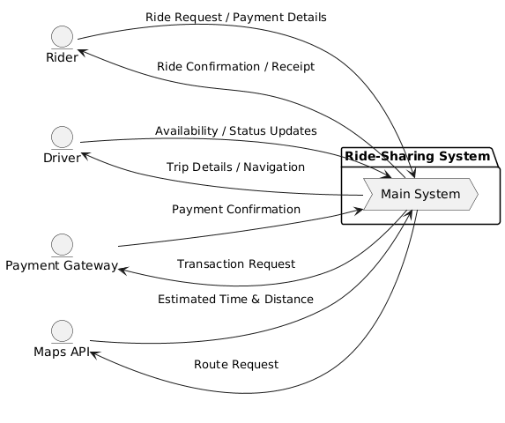

A Data Flow Diagram (DFD), specifically a Level 0 Context Diagram, acts like a high-level "bird's-eye view" of a system. It shows how the system interacts with the outside world without getting bogged down in the complex technical details of what is happening inside.
Using the provided ride-sharing diagram as an example, here is how you can understand its components:
1. The Central System (The "Black Box")
The large box labeled Ride-Sharing System represents the entire application (the software on your phone and the servers that run it). At this level, we treat the "Main System" as a single process that handles all requests.
2. External Entities (The People and Services)
The circles on the left represent External Entities—the people or outside services that interact with the system:
- Rider: The person looking for a ride.
- Driver: The person providing the service.
- Payment Gateway: An outside service (like Stripe or PayPal) that handles the actual money.
- Maps API: An outside service (like Google Maps) that calculates routes and traffic.
3. Data Flows (The Information Exchange)
The arrows show exactly what information is being passed back and forth. Think of these as the "conversations" between the user and the app:
- Rider → System: The Rider sends Ride Request / Payment Details to start the process.
- System → Rider: Once a driver is found, the system sends back a Ride Confirmation / Receipt.
- Driver ↔ System: The Driver tells the system their Availability, and in return, the system sends them Trip Details / Navigation so they know where to go.
- System ↔ Outside Services: The system asks the Maps API for a Route Request and receives the Estimated Time & Distance. It also sends a Transaction Request to the Payment Gateway to ensure the driver gets paid.
Summary of the Flow
In short, this diagram tells a story: A Rider asks for a trip, the System checks with Maps for the route and finds a Driver, and once the trip is done, it uses a Payment Gateway to finish the job and notifies the Rider.

2. Level 1: Decomposed DFD
The Level 1 DFD breaks the system into major functional modules and identifies data stores.
Major Processes:
- User Management: Handles registration and profiles.
- Ride Matching: Connects Riders with nearby Drivers.
- Trip Tracking: Manages real-time GPS updates.
- Payment Processing: Manages billing and payouts.
PlantUML Code (Level 1 DFD):
Code snippet
@startuml
left to right direction

entity "Rider" as R
entity "Driver" as D

storage "User DB" as DB1
storage "Ride DB" as DB2
storage "Payment DB" as DB3

package "Processes" {
process "1.0 User Management" as P1
process "2.0 Ride Matching" as P2
process "3.0 Trip Tracking" as P3
process "4.0 Payment Processing" as P4
}

R --> P1 : Profile Info
P1 --> DB1 : Save User
R --> P2 : Ride Request
P2 --> DB2 : Log Trip
DB1 --> P2 : Get Driver Availability
P2 --> D : Notification
D --> P3 : GPS Updates
P3 --> DB2 : Update Location
P3 --> P4 : Trip Completed
P4 --> DB3 : Record Transaction
@enduml

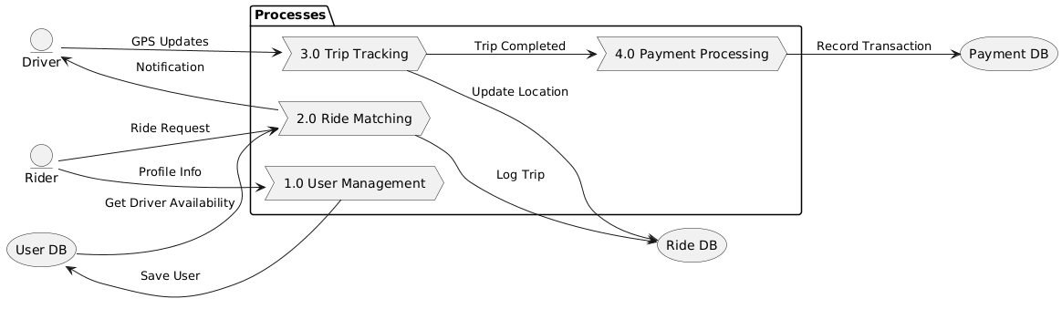

Based on the provided images, a Data Flow Diagram (DFD) is a visual map that shows how information moves through a system. It identifies where data comes from (External Entities), where it goes (Processes), and where it is stored (Data Stores).
Here is a beginner-friendly explanation of the two DFD levels shown:
1. Level 0: The Big Picture (Context Diagram)
The Context Diagram shows the entire "Ride-Sharing System" as one single bubble. It focuses on how the system talks to the outside world.
- The Entities (The People and Services): These are the circles on the left.
  - Rider: Sends a request for a ride and payment details; receives a confirmation and receipt.
  - Driver: Provides their status (available/busy) and receives navigation details to find the rider.
  - Payment Gateway: Receives transaction requests from the system and sends back a confirmation once the payment clears.
  - Maps API: Receives route requests and provides estimated time and distance back to the system.

2. Level 1: Looking Under the Hood (Decomposed DFD)
The Level 1 Diagram breaks that one big "Main System" bubble into smaller, specific tasks (Processes) and shows where the information is saved (Data Stores).
The Major Processes:
- 1.0 User Management: When a Rider provides "Profile Info," this process handles it and uses the Save User flow to store it in the User DB.
- 2.0 Ride Matching: This is the "brain" that connects people. It takes a Ride Request from the Rider, checks the User DB to see which drivers are available, and sends a Notification to the Driver.
- 3.0 Trip Tracking: Once the ride starts, the Driver sends GPS Updates. This process updates the Ride DB with the current location.
- 4.0 Payment Processing: When the trip is finished, the system triggers this process to Record the Transaction in the Payment DB.
The Data Stores (The File Cabinets):
- User DB: Stores information about riders and drivers.
- Ride DB: Keeps a log of every trip, including where it started and where it ended.
- Payment DB: A secure record of all money exchanged.
How it connects to the Database (ERD)
While the DFD shows the movement of data, the Entity Relationship Diagram (ERD) shows the structure of that data. For example, the "Ride Matching" process in the DFD relies on the relationships defined in an ERD—ensuring that every Registration (or ride) is correctly linked to one Student (rider) and one Course (trip/driver).

3. Database Schema (3NF)
For a ride-sharing app, we ensure 3rd Normal Form (3NF) to avoid data redundancy.
SQL Schema (schema.sql):
SQL
-- 1. Users Table (Riders and Drivers)
CREATE TABLE Users (
UserID INT PRIMARY KEY,
FullName VARCHAR(100),
Email VARCHAR(100) UNIQUE,
PhoneNumber VARCHAR(20),
UserType ENUM('Rider', 'Driver')
);

-- 2. Drivers Detail Table (Prevents nulls in Users table for Riders)
CREATE TABLE DriverDetails (
DriverID INT PRIMARY KEY,
LicenseNumber VARCHAR(50),
VehicleInfo VARCHAR(100),
Rating DECIMAL(3,2),
FOREIGN KEY (DriverID) REFERENCES Users(UserID)
);

-- 3. Rides Table
CREATE TABLE Rides (
RideID INT PRIMARY KEY,
RiderID INT,
DriverID INT,
PickupLocation VARCHAR(255),
DropoffLocation VARCHAR(255),
Status ENUM('Requested', 'In-Progress', 'Completed', 'Cancelled'),
FOREIGN KEY (RiderID) REFERENCES Users(UserID),
FOREIGN KEY (DriverID) REFERENCES Users(UserID)
);

-- 4. Payments Table
CREATE TABLE Payments (
PaymentID INT PRIMARY KEY,
RideID INT,
Amount DECIMAL(10,2),
PaymentStatus ENUM('Pending', 'Success', 'Failed'),
TransactionDate DATETIME,
FOREIGN KEY (RideID) REFERENCES Rides(RideID)
);

4. Deliverables
Presentation
View Presentation: Ride-Sharing System Design Walkthrough
- Slide 1: System Overview & External Entities.
- Slide 2: Level 0 Context DFD (Interactions).
- Slide 3: Level 1 DFD (Internal Data Flow).
- Slide 4: Database Mapping (How Ride Matching process populates the Rides table).
GitHub Repository
GitHub Repo: RideShare-Architecture
- /diagrams: Includes .puml and .png files for DFDs.
- /sql: Includes schema.sql.
- README.md: Documentation for the project.

